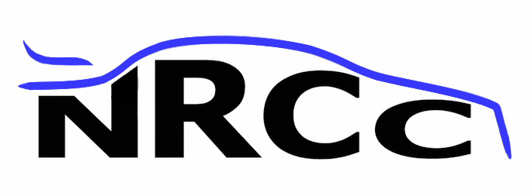 |  |  | Newbury RC Club  Membership Form 2017
Name :
Address :
Postcode :
Phone No : |  |  |  |  |  |  | Mobile :
Email address :
Frequency | 40MHz 27MHz 2.4GHz if 2.4GHz skip Crystals.
Crystals :  (min of 3) | 27MHz |  |  | 40MHz
Crystals :  (min of 3) | Brown | Gr/Br |  | 665 | 725 |  |  | 785 |  | 845 |  | 905 | 965
Crystals :  (min of 3) | Red | R/Br |  | 675 | 735 |  |  | 795 |  | 855 |  | 915 | 975
Crystals :  (min of 3) | Orange | R/Or |  | 685 | 745 |  |  | 805 |  | 865 |  | 925 | 985
Crystals :  (min of 3) | Yellow | O/Y |  | 695 | 755 |  |  | 815 |  | 875 |  | 935 | 995
Crystals :  (min of 3) | Green | Y/G |  | 705 | 765 |  |  | 825 |  | 885 |  | 945
Crystals :  (min of 3) | Blue | Bl/G |  | 715 | 775 |  |  | 835 |  | 895 |  | 955
Date of birth : | if under 16 on 1st January 2017
PT number : |  |  |  |  |  | BRCA number :
Signed : |  |  |  |  |  | Date :
Signed : | I agree to abide by current BRCA regulations and club rules  I give my consent for photos and videos taken at club meetings in which I appear to be shown on the club’s website
Membership fees : | Club membership only (adult)  Club membership only (junior) |  |  |  |  | £15  £8 |  |  |   NRCC is a BRCA affiliated club

Newbury RC Club holds personal data in respect of its members on a computer, in accordance with the Data Protection Act 1984, the club may use such data for the following purposes:
- disclosures to authorised officers of the club for the purposes of day to day membership administration
- the publication from time to time of a membership list for the exclusive use of members in pursuit of their hobby and not for any trade purposes.

